Deploy Embeddings in Microsoft Foundry
- Login to Azure Portal.

- Go to Microsoft Foundry Project to access and deploy embeddings.

- Click Discover menu item to get to Models.

- Click Models menu item to see available models and embeddings.
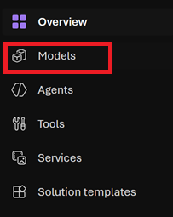
- Enter Model or Embedding Search Criteria in Search textbox and double-click on desired Embeddings Model.
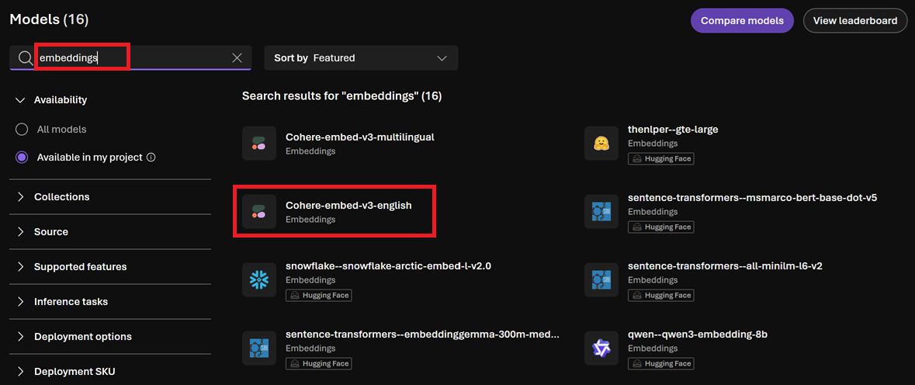

- Click Deploy button and select Custom settings to deploy model.
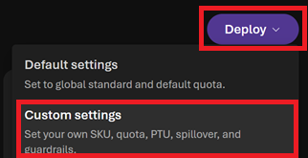

- Click Agree and proceed button to proceed with model deployment.
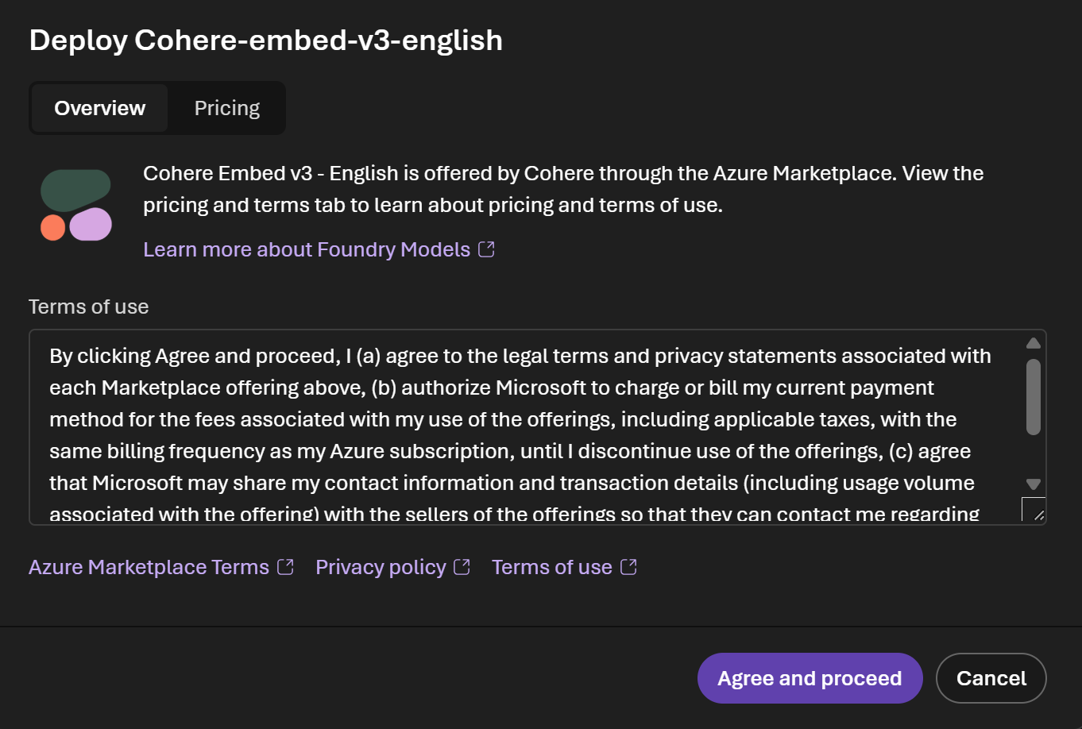

- Enter a add text suffix to Deployment name to make it unique and click Deploy button to deploy the model.
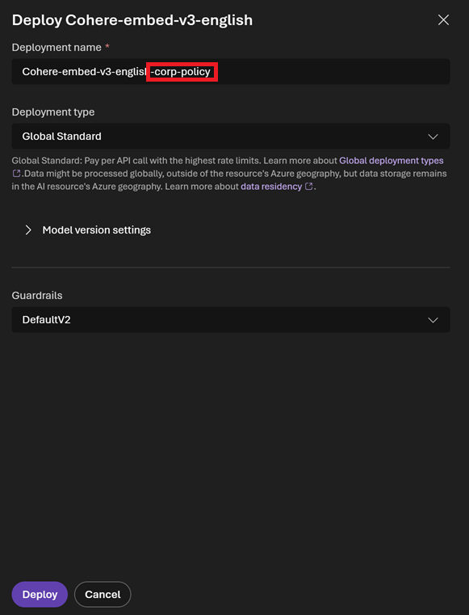
- Click Build menu item to get to Deployments window.
- Click Deployments menu item to see what has been deployed.
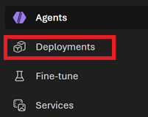

- See recently deployed Embeddings Model.
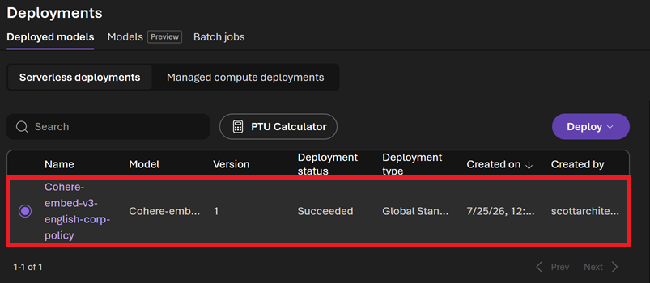
- Finished.

